
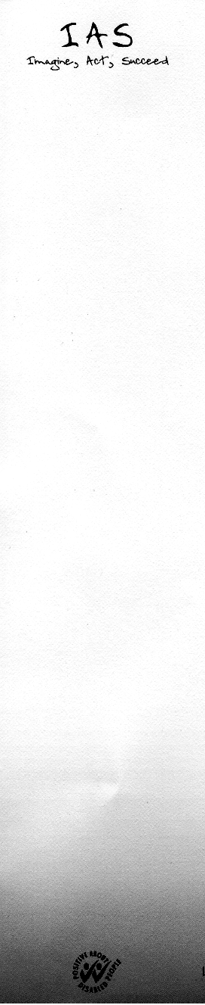

IAS EQUALITY AND DIVERSITY MONITORING

IAS (Services) Ltd strives to operate a policy of equal opportunity and not discriminate against any person on the grounds of age, disability, ethnicity, gender, religion or belief or sexual orientation.

In order to assist with monitoring the effectiveness of our staff recruitment in relation to Equality and Diversity, please complete this form. The purpose of this form is to enable us to produce depersonalised monitoring statistics.

IMPORTANT - Please note that this form is removed from your application when it arrives and is filed separately. The information contained within is not made available to short listing or interviewing panels.

Name:

Post: | Ref Number: | Date:

Are you already an employee of IAS? YES/NO

If yes please give details:

SECTION 1 – AGE

Are you aged
Between 18-21 □
Between 21-35 □
Between 35-50 □
Between 50-65 □
Between 65-70 □
Prefer not to say □

SECTION 2 – DISABILITY

Do you consider yourself to have a disability? YES/NO

A person has a disability if he/she has a physical or mental impairment, which has a substantial and long term adverse effect on his/her ability to carry out normal day to day activities.

If yes please provide a brief description

Please Turn Over

SECTION 3 - ETHNICITY

What is your ethnic group?
Choose ONE section from A-G, then select the appropriate box to indicate your cultural background

A White
British □
Irish □
Other (please state) □

B Mixed
Any mixed background (please state) □

C Asian, Asian British
Indian □
Pakistani □
Bangladeshi □
Chinese □
Any other Asian background (please state) □

D Black, Black British
Caribbean □
African □
Any other Black background, (please state) □

E Other ethnic background
Any other background (please state) □

F Not known
Not known □

G Prefer not to say
Prefer not to say □

SECTION 4 – GENDER

Are you
Male □
Female □

THANK YOU FOR YOUR ASSISTANCE

